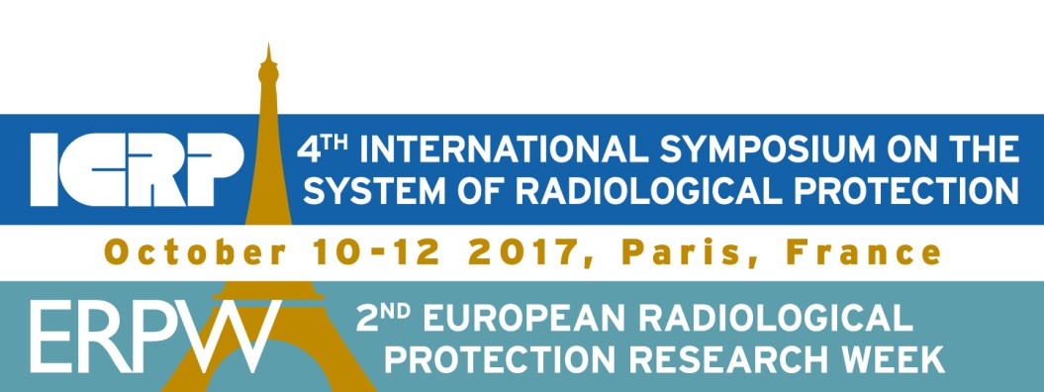

Policy on booth exhibition for ICRP-ERPW event – October 10-12, 2017

The International Commission on Radiological Protection (ICRP) and the European Research Platforms [MELODI (low dose effects and risks), EURADOS (dosimetry), NERIS (emergency and recovery preparedness), ALLIANCE (radioecology) and EURAMED (medical radiation protection)] are joining their forces to organize an exceptional combined international event in Paris – France on October 10-12th, 2017. The event will be hosted by the French Radiation Protection and Nuclear Safety Institute (IRSN).

For ICRP it will be the 4th International Symposium on the System of radiological Protection and for the European Research Platforms, it will be the 2nd European Radiation Protection Research Week.

ICRP has spent nearly nine decades developing and updating the System of Radiological Protection that forms the fundamental basis for standards, guidance, and practice in radiation safety. This System protects millions of patients, workers, and members of the public all over the world every day. However, the science on which this system is based is in parallel evolving through research. The European research platforms in particular address fundamental questions on radiation effects and related risks, as well as technical, societal and organizational scientific issues relevant to the optimization of radiation protection.

This combined event will offer the opportunity for more than 600 professionals, experts and researchers worldwide to discuss their respective concerns and the current challenges faced in all areas of radiological protection, as well as the ways forward through new research, updating doctrines, or better interactions with stakeholders.

It is with pleasure that we invite you to participate and to benefit from a programme tightly focused on the most important topics in radiological protection today. This will also be a rare opportunity to interact directly with many members of ICRP and of the platforms who are top experts and researchers in the field.

Because both ICRP and the European platforms are non-profit organizations, an international collaboration is necessary to support this event and make it possible. Therefore the organizing Committee has planned to welcome exhibition booths at the event. However, this event should also convey the message to society that radiation protection research is not compromised by commercial interests. This is a key issue for the public credibility of science in this sensitive field, with public health and environmental protection concerns. Consequently, industry and other stakeholders participating in the sponsoring of the event, particularly with a booth, will be engaged to restrict their communication to research and educational issues, excluding any promotion of commercial products or services.

Meanwhile, should you have any questions, please do not hesitate to contact us for further information.

EXHIBITOR APPLICATION FORM
COMPANY DETAILS
Institution
Contact person |  |  | Position
Address
City |  |  | Zip code
Country |  |  | State
Phone number
Email
VAT Number
PROPOSED TOPICS (research, education…) see the policy on booth exhibition
EXHIBITION
Booth Number(s) | 1st choice: | 2nd choice: |  | 3rd choice:
Shell scheme package:  2 entries per booth  3mx3m  Octanorm  Plug point  Fascia  Table and 2 chairs | Price per booth  3000,00€ VAT inc. | Number of booths  1 - 3000,00€  2 - 6000,00€  3 - 9000,00€  4 - 12000,00€ |  | I am aware of the financial and administrative conditions for Exhibitors and I agree to abide by those conditions.
One extra entry | 150,00€ VAT inc. | Number: |  | Total:
Signature and company stamp
Name |  |  | Date
IRSN BANK ACCOUNT – Payment shall be made by the exhibitors by wire transfer on the following bank account:
Domiciliation bancaire………………………………..TPPARIS RGF
Titulaire du compte…………………………………….IRSN INST. RADIOPROT.SURETE NUC.
Code banque………………………………………………10071
Code guichet………………………………………………75000
N° Compte…………………………………………………00001000548
Clé RIB………………………………………………………85
IBAN: FR76 / 1007 / 1750 /0000 / 0010 / 0054 / 885
Swift ou BIC code: BDFEFRPPXXX
Bank address: Recette Générale des Finances - 94 rue Réaumur - 75104 PARIS CEDEX 02

Please send this application form to the following email address : icrp-erpw2017@irsn.fr

